**COVID-19 RDT Capture System Design Document**

Last updated 12th December 2021

Package version: 0.1

DHIS2 Version compatibility 2.36 and above

Demo: <https://links.hispindia.org/rdt_capture>

# 

**Purpose** **2**

**System Design Summary** **2**

**Intended users** **3**

**Workflow** **4**

**Program Structure: COVID19 RDT Capture** **5**

**Program Description** **6**

Registration and Enrollment 7

Program Stage 1 - COVID19 RDT Capture 8

Section 1 - Test Reference Details 8

Section 2 - Test Reason 8

Section 3 - Symptoms 9

Section 4 - RDT Details 9

Section 5 - RDT Result 10

Section 6 - RDT Repeat Test 11

Section 7 - RDT Standard Fields 11

**Program Rules** **12**

Program Indicators and Indicators **14**

# 

# Purpose

The COVID-19 RDT Capture System Design Document provides an overview of the conceptual design which has been used to configure the COVID19 RDT Capture digital data package in DHIS2. The development effort for this package is aimed at supporting the LMIC countries in easy collection of COVID19 antigen RDT results for use in patient care, disease surveillance to support the pandemic response.

This document is intended for use by DHIS2 implementers at the country and regional level to be able to support the implementation and localisation of the package. The COVID19 RDT Capture metadata package can be adapted to local needs and national guidelines. In particular, local workflows and national guidelines should be considered in the localization and adoption of the programs included in this package.

# 

# System Design Summary

COVID-19 RDT Capture enrols cases that need testing for COVID19 via RDT test kits to get a confirmatory test done. The program captures details of test administrator, test-setting, the reason for conducting the test, the symptoms presented by the patient in case of being symptomatic, followed by RDT test details, RDT results, and provision for adding details of repeat RDT test in case it is carried out due to invalid/indeterminate results in the first attempt.

This package can be installed as a standalone package or can be integrated into a country’s existing integrated disease surveillance & response tracker.

Digital data packages are optimized for Android data collection with the DHIS2 Capture App, free to download on the [Google Play store](https://play.google.com/store/apps/details?id=com.dhis2&hl=en).

The COVID-19 RDT Capture tracker can be adapted and used by countries to supplement existing COVID19 disease surveillance programs. The COVID19 RDT Capture program is designed to

1. Enrol suspected COVID-19 cases/ close contacts of COVID19 case / symptomatic cases generally appearing at a health facility, but may be enrolled at other places such as Community while contact tracing exercise.
2. Capture key information about the suspected case including demographics, test reason, symptoms (if applicable).
3. Capture details of the RDT test administrator
4. Capture details of the RDT test and its result.
5. Generate dashboards and analytics tools for monitoring COVID19 testing trends and planning response efforts.

# 

# Intended users

1. Health facility users: capture and record details about a suspected case, RDT test details and RDT test result for tests carried out at health facility or home visit.
2. Laboratory users: capture and record details about a suspected case, RDT test details and RDT test result at the laboratory.
3. National and local health authorities: monitor and analyse COVID19 RDT testing data through dashboards and analytics tools to plan response measures; generate reports for national reporting.

# 

# Workflow

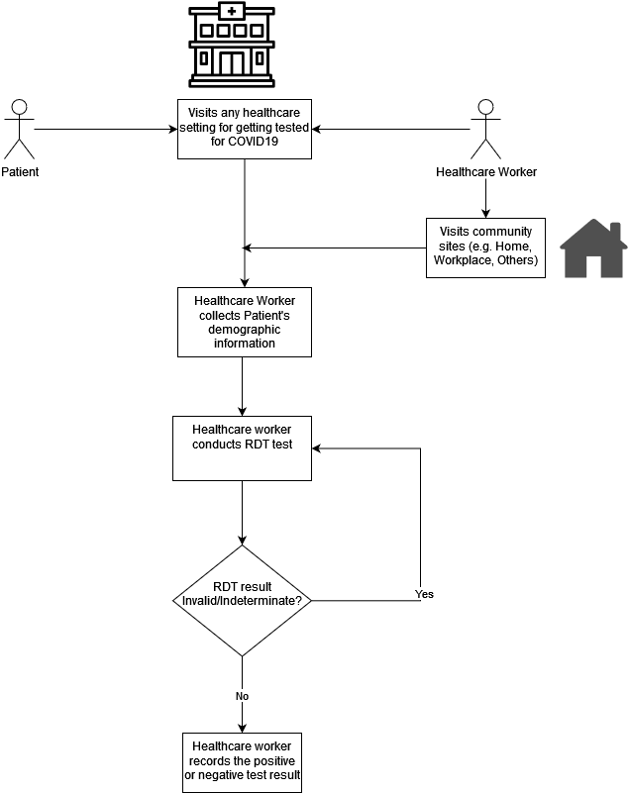

# 

# Program Structure: COVID19 RDT Capture



# Program Description

| **Stage** | **Description** |
| --- | --- |
| **Enrollment details**  **Attributes** | 1. The Tracked Entity is the case, which is represented by a Tracked Entity Type of ‘Person.’ 2. Enrollment date : Date when the patient was enrolled in the program.   Attributes include basic personal information and unique case identifiers   1. Patient ID (auto-generated) 2. Patient First Name 3. Patient Family Name 4. Patient Birth Date 5. Age 6. Sex 7. Contact Number 8. Address |
| **Stage 1: COVID19 RDT Capture**  **(Repeatable)** | This stage records details of the COVID19 RDT test done for a patient. The information is collected under the following sections:   1. Test Reference Details 2. Test Reasons 3. Symptoms 4. RDT Details 5. RDT Results 6. RDT Repeat Results 7. Additional Remarks 8. RDT Standard Fields |

### 

### **Registration and Enrollment**

## 

### Program Stage 1 - COVID19 RDT Capture

#### Section 1 - Test Reference Details

1. The Session ID and Test ID, both are automatically generated, which is a combination of Patient ID + Date of RDT Test.
2. Administrator ID or Administrator Name, one of these fields has to be entered.

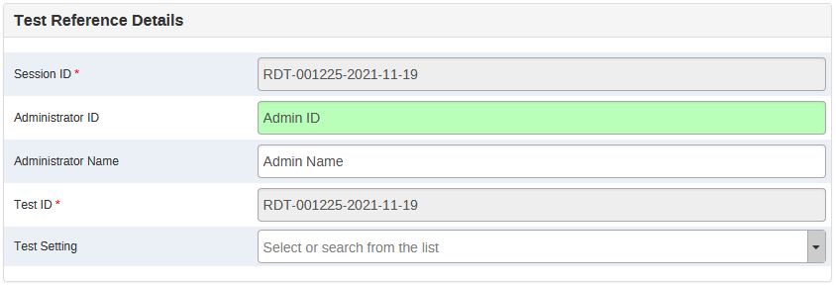

#### Section 2 - Test Reason

1. There are 4 test reasons to choose from as shown below.
2. The Symptomatic data element will hide in case Asymptomatic is selected by the user.

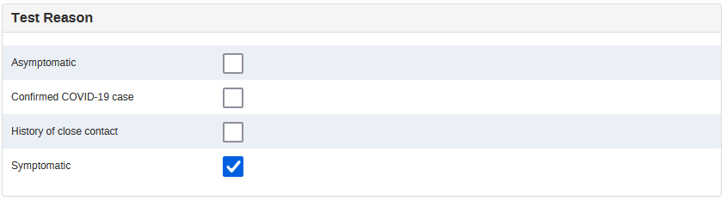

#### Section 3 - Symptoms

1. This section is hidden unless ‘Symptoms’ in the above section is ticked.

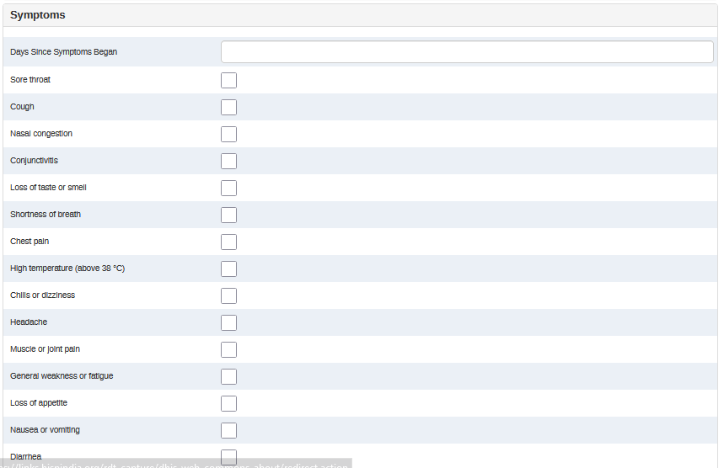

#### Section 4 - RDT Details

1. The RDT Name has a pre-defined list of approved RDT test kits, including Other option to specify other available kits.
2. The Specimen Type data element has a predefined list of specimens, including Other option to specify other sample types.
3. When the user reports a date of the past as compared to the RDT test date, the warning and RDT Expired data element show up, and RDT Expired becomes a mandatory field for the user to confirm that the expired RDT test kit is/was being used.

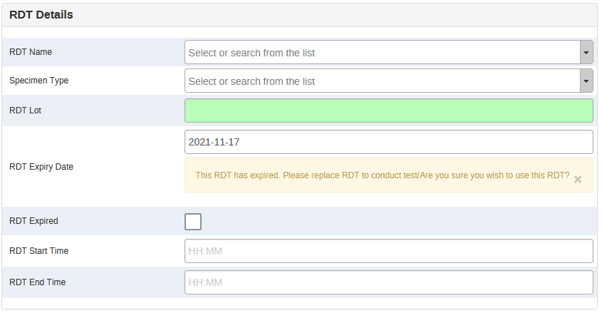

#### Section 5 - RDT Result

This section is used to record the result of the RDT test carried out, along with the image of the RDT test result.

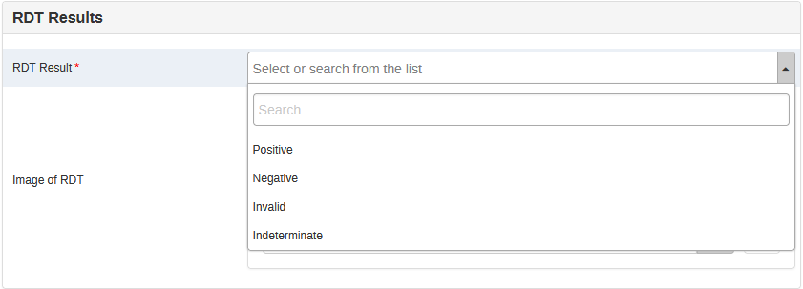

#### Section 6 - RDT Repeat Test

1. This section shows only when the result of the first RDT test is ‘Invalid’ or ‘Indeterminate’
2. The additional details of the repeat RDT test are shown by ‘Yes’ is selected for the ‘Do you want to do a repeat test?’
3. The Test ID for the repeat test is automatically generated, by adding ‘-1’ to the first Test ID generated in the Test Reference Details section.

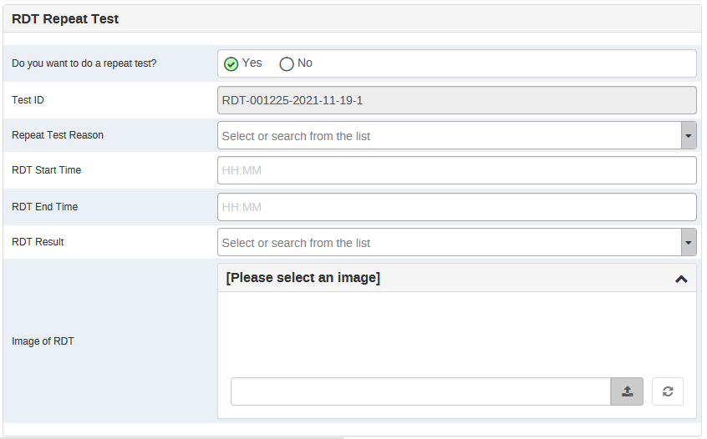

# 

#### Section 7 - RDT Standard Fields

This section contains auto-assigned values RDT LOINC Code, RDT LOINC Name, and Syndrome test type.

# Program Rules

The following program rules have been configured.

| **S.No.** | **Program Rule Name** | **Program Rule Description** |
| --- | --- | --- |
| 1 | Calculate and assign patient age in years | Calculate and assign patient age in years based on DOB. |
| 2 | Assign session ID in test reference details | Assigns session ID as a combination of a patient ID and date of RDT test. |
| 3 | Assign Session ID to Test ID | Assigns the session ID to the test ID field. |
| 4 | Assign repeat test ID, if RDT test is repeated, | Assigns a new test ID in case a repeat RDT test is conducted. |
| 5 | Assign predefined values for RDT standard fields | Assigns RDT LOINC Code, LOINC Name, Syndrome test type to data elements for data analysis. |
| 6 | Hide data element RDT expired if the expiry date is after RDT test date | Hides RDT Expired data element if the expiry date is in the future when compared to the RDT test date. |
| 7 | Hide other RDT name if other RDT test name is not selected | Hides other RDT name if RDT test name if other is not selected in the RDT name data element. |
| 8 | Hide other reason for RDT if another reason is not selected | Hides other reason for repeat RDT test is other is not selected in the reason for repeat RDT test. |
| 9 | Hide other specimen types for RDT if another specimen type is not selected | Hides other specimen type if other is not selected in the specimen type data element. |
| 10 | Hide RDT repeat test details if repeat test is not done | Hides all details of the repeat RDT test if ‘Yes’ is not selected for the RDT repeat test data element. |
| 11 | Hide RDT repeat test section till the result is not invalid or indeterminate | Hides RDT Repeat Test section if the test result of previous test is not invalid or indeterminate. |
| 12 | Hide RDT standard fields section | Hides RDT standard fields section as it is only required for data analysis, and no data input is done. |
| 13 | Hide symptoms data element if the patient is reported to be asymptomatic | Hides ‘Symptoms’ data element is patient is reported to be ‘Asymptomatic’ |
| 14 | Hide symptoms section if the patient is reported to be asymptomatic | Hide the ‘Symptoms’ section if there is no value reported for ‘Symptoms’ data element. |
| 15 | Make field mandatory admin ID | Makes the Administrator ID field mandatory if no value is reported for the Administrator name. |
| 16 | Make field mandatory admin name | Makes the Administrator name field mandatory if no value is reported for the Administrator ID. |
| 17 | Show warning RDT expired if the expiry date is before RDT test date and make RDT expired field mandatory | Shows warning when RDT test date is beyond the RDT expiry date and makes the RDT expired field mandatory for a response for users. |
| 18 | Make fields mandatory if the RDT test is repeated | Makes the repeat RDT test details fields mandatory when a repeat test is done. |
| 19 | Make repeat test field mandatory | Makes the RDT repeat test data element mandatory if the previous test result was invalid or indeterminate. |

You can read more about program rules here:

<https://docs.dhis2.org/master/en/user/html/configure_program_rule.html>

## 

# Program Indicators and Indicators

| **S.No.** | **Program Indicators** | **Indicators** |
| --- | --- | --- |
| 1 | COVID19 indeterminate tests | COVID19 indeterminate tests (%) |
| 2 | COVID19 invalid tests | COVID19 invalid tests (%) |
| 3 | COVID19 negative tests | COVID19 negative tests (%) |
| 4 | COVID19 positive cases | COVID19 people tested (0-15 years) (%) |
| 5 | COVID19 positive tests | COVID19 people tested (15-30 years) (%) |
| 6 | COVID19 tests completed | COVID19 people tested (30-45 years) (%) |
| 7 | COVID19 tests completed (0 - 15 years) | COVID19 people tested (45-60 years) (%) |
| 8 | COVID19 tests completed (15 - 30 years) | COVID19 people tested (75+ years) (%) |
| 9 | COVID19 tests completed (30 - 45 years) | COVID19 people tested (female) (%) |
| 10 | COVID19 tests completed (45-60 years) | COVID19 people tested (male) (%) |
| 11 | COVID19 tests completed (75+ years) | COVID19 positive tests (%) |
| 12 | COVID19 tests completed (female) | COVID 19 positivity rate |
| 13 | COVID19 tests completed (male) | COVID19 test setting - Community - Home (%) |
| 14 | COVID19 test setting - Community - Home | COVID19 test setting - Community - Others (%) |
| 15 | COVID19 test setting - Community - Other | COVID19 test setting - Community - Workplace (%) |
| 16 | COVID19 test setting - Community - Workplace | COVID19 test setting - Healthcare - Clinic (%) |
| 17 | COVID19 test setting - Healthcare - Clinic | COVID19 test setting - Healthcare - Hospital (%) |
| 18 | COVID19 test setting - Healthcare - Hospital | COVID19 test setting - Healthcare - Others (%) |
| 19 | COVID19 test setting - Healthcare - Others | Symptoms - Anxiety (%) |
| 20 | Indeterminate cases | Symptoms - Chest pain (%) |
| 21 | Invalid cases | Symptoms - Chills or dizziness (%) |
| 22 | Negative cases | Symptoms - Confusion (%) |
| 23 | People tested for COVID19 | Symptoms - Conjunctivitis (%) |
| 24 | Symptomatic cases | Symptoms - Cough (%) |
| 25 | Symptoms - Anxiety | Symptoms - Depression (%) |
| 26 | Symptoms - chest pain | Symptoms - Diarrhea (%) |
| 27 | Symptoms - Chills or dizziness | Symptoms - General weakness or fatigue (%) |
| 28 | Symptoms - Confusion | Symptoms - Headache (%) |
| 29 | Symptoms - Conjunctivitis | Symptoms - High temperature (above 38 Â°C) (%) |
| 30 | Symptoms - Cough | Symptoms - Irritability (%) |
| 31 | Symptoms - Depression | Symptoms - Loss of appetite (%) |
| 32 | Symptoms - Diarrhea | Symptoms - Loss of taste or smell (%) |
| 33 | Symptoms - General weakness or fatigue | Symptoms - Muscle or joint pain (%) |
| 34 | Symptoms - Headache | Symptoms - Nasal congestion (%) |
| 35 | Symptoms - High temperature (above 38 °C) | Symptoms - Nausea or vomiting (%) |
| 36 | Symptoms - Irritability | Symptoms - Neurologic complications (%) |
| 37 | Symptoms - Loss of appetite | Symptoms - Shortness of breath (%) |
| 38 | Symptoms - Loss of taste or smell | Symptoms - Skin rash (%) |
| 39 | Symptoms - Muscle or joint pain | Symptoms - Sleep disorders (%) |
| 40 | Symptoms - Nasal congestion | Symptoms - Sore throat (%) |
| 41 | Symptoms - Nausea or vomiting |  |
| 42 | Symptoms - Neurologic complications |  |
| 43 | Symptoms - Shortness of breath |  |
| 44 | Symptoms - Skin rash |  |
| 45 | Symptoms - Sleep disorders |  |
| 46 | Symptoms - Sore throat |  |